11.3 Area – GP3

To create these, copy the shapes from XL into paint.net. Use paint.net to give them the right color background, then paste them into this document to label them. Most of these were captured at 110%

10 feet

45 feet

20 x 45 = 900

(3.14 x 100) /2 = 157

3.14 x 64 = 201

1255 square feet

20 feet

Main lawn

Driveway circle

16 feet

MAIN LAWN

RADIUS

45 feet

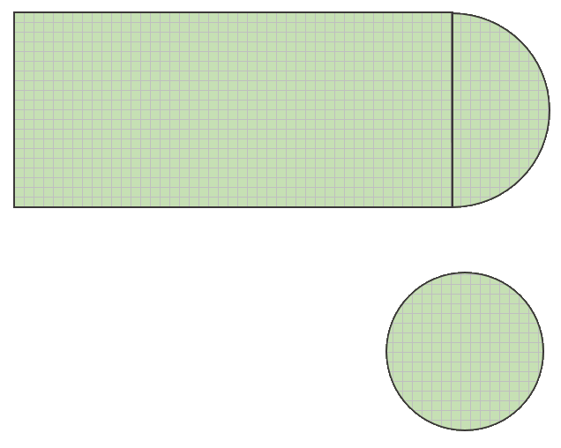

16 feet

DRIVEWAY CIRCLE

10 feet

20 feet

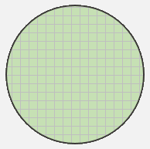

DIAMETER

RADIUS

RADIUS

LENGTH

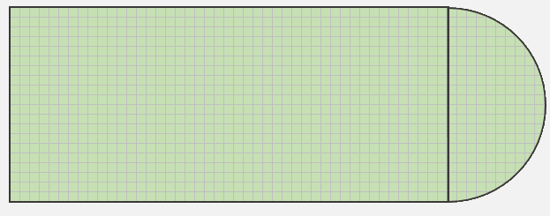

WIDTH

DRIVEWAY CIRCLE

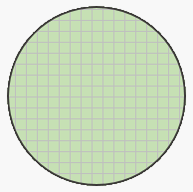

radius = 8 feet

16 feet

Captured at 110%

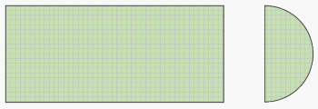

Shape 2:

Semi-circle with

radius = 10

Shape 1:

20 x 45 rectangle

45 feet

RADIUS

20 feet

10 feet

Captured at 110%

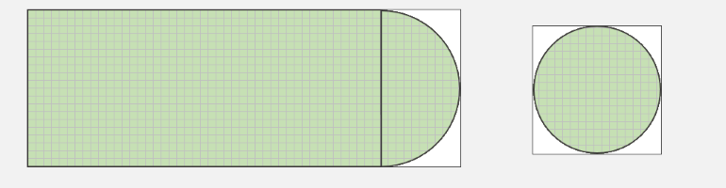

10 feet

45 feet

16 feet

16 feet

20 feet

55 feet

The white boxes for these were added in paint.net. Captured at 110%